**2.SQL EXERCISE INDEX**

**HANDS ON**

-- Drop tables

DROP TABLE IF EXISTS OrderDetails;

DROP TABLE IF EXISTS Orders;

DROP TABLE IF EXISTS Products;

DROP TABLE IF EXISTS Customers;

-- Create tables

CREATE TABLE Customers (

CustomerID INT PRIMARY KEY,

Name VARCHAR(100),

Region VARCHAR(50)

);

CREATE TABLE Products (

ProductID INT PRIMARY KEY,

ProductName VARCHAR(100),

Category VARCHAR(50),

Price DECIMAL(10,2)

);

CREATE TABLE Orders (

OrderID INT PRIMARY KEY,

CustomerID INT,

OrderDate DATE,

FOREIGN KEY (CustomerID) REFERENCES Customers(CustomerID)

);

CREATE TABLE OrderDetails (

OrderDetailID INT PRIMARY KEY,

OrderID INT,

ProductID INT,

Quantity INT,

FOREIGN KEY (OrderID) REFERENCES Orders(OrderID),

FOREIGN KEY (ProductID) REFERENCES Products(ProductID)

);

-- Insert data

INSERT INTO Customers (CustomerID, Name, Region) VALUES

(1,'Alice','North'),

(2,'Bob','South'),

(3,'Charlie','East'),

(4,'David','West');

INSERT INTO Products (ProductID, ProductName, Category, Price) VALUES

(1,'Laptop','Electronics',1200.00),

(2,'Smartphone','Electronics',800.00),

(3,'Tablet','Electronics',600.00),

(4,'Headphones','Accessories',150.00);

INSERT INTO Orders (OrderID, CustomerID, OrderDate) VALUES

(1,1,'2023-01-15'),

(2,2,'2023-02-20'),

(3,3,'2023-03-25'),

(4,4,'2023-04-30');

INSERT INTO OrderDetails (OrderDetailID, OrderID, ProductID, Quantity) VALUES

(1,1,1,1),

(2,2,2,2),

(3,3,3,1),

(4,4,4,3);

-- Create indexes

CREATE NONCLUSTERED INDEX IX_Products_ProductName ON Products(ProductName);

CREATE NONCLUSTERED INDEX IX_Orders_OrderDate ON Orders(OrderDate);

CREATE NONCLUSTERED INDEX IX_Orders_CustomerID_OrderDate ON Orders(CustomerID, OrderDate);

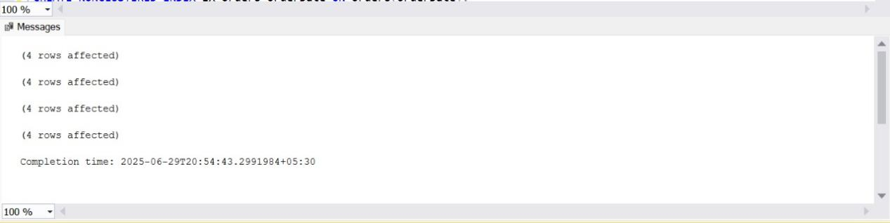

**SQL EXERCISE FUNCTIONS**

**Exercise 7: Return Data From a Scalar Function**

DROP FUNCTION IF EXISTS dbo.fn_CalculateAnnualSalary;

GO

DROP TABLE IF EXISTS Employees;

GO

DROP TABLE IF EXISTS Departments;

GO

CREATE TABLE Departments (

DepartmentID INT PRIMARY KEY,

DepartmentName VARCHAR(100)

);

GO

CREATE TABLE Employees (

EmployeeID INT PRIMARY KEY,

FirstName VARCHAR(50),

LastName VARCHAR(50),

DepartmentID INT,

Salary DECIMAL(10, 2),

JoinDate DATE,

FOREIGN KEY (DepartmentID) REFERENCES Departments(DepartmentID)

);

GO

CREATE FUNCTION dbo.fn_CalculateAnnualSalary (@MonthlySalary DECIMAL(10, 2))

RETURNS DECIMAL(10, 2)

AS

BEGIN

RETURN @MonthlySalary * 12;

END;

GO

INSERT INTO Departments (DepartmentID, DepartmentName)

VALUES

(1, 'HR'),

(2, 'IT'),

(3, 'Finance');

GO

INSERT INTO Employees (EmployeeID, FirstName, LastName, DepartmentID, Salary, JoinDate)

VALUES

(1, 'John', 'Doe', 1, 5000.00, '2020-01-15'),

(2, 'Jane', 'Smith', 2, 6000.00, '2019-03-22'),

(3, 'Bob', 'Johnson', 3, 5500.00, '2021-07-01');

GO

SELECT

e.EmployeeID,

e.FirstName,

e.LastName,

d.DepartmentName,

e.Salary AS MonthlySalary,

dbo.fn_CalculateAnnualSalary(e.Salary) AS AnnualSalary

FROM Employees e

JOIN Departments d ON e.DepartmentID = d.DepartmentID

ORDER BY e.EmployeeID;

GO

SELECT dbo.fn_CalculateAnnualSalary(1) AS AnnualSalary;

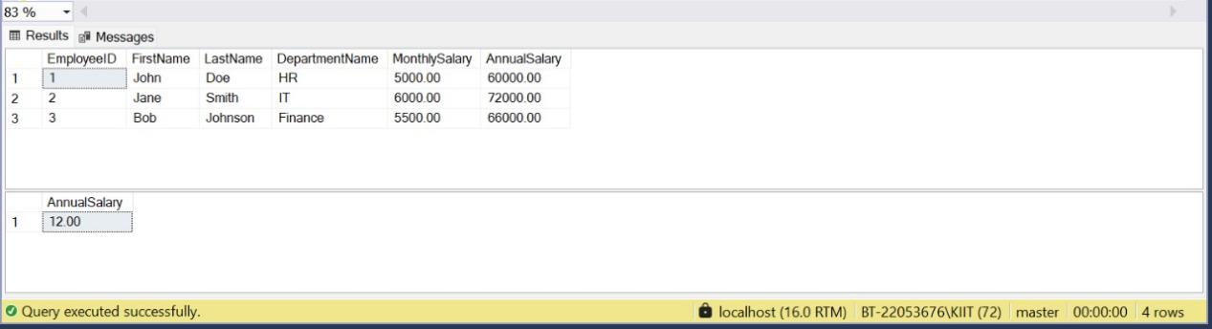

**SQL EXERCISE STORED PROCEDURE**

**EXERCISE 4 : Executed a Stored procedure**

-- Drop stored procedure if it exists

DROP PROCEDURE IF EXISTS dbo.GetEmployeesByDepartment;

GO

-- Drop tables if they exist

DROP TABLE IF EXISTS dbo.Employees;

DROP TABLE IF EXISTS dbo.Departments;

GO

CREATE TABLE dbo.Departments (

DepartmentID INT PRIMARY KEY,

DepartmentName VARCHAR(100)

);

GO

CREATE TABLE dbo.Employees (

EmployeeID INT PRIMARY KEY,

FirstName VARCHAR(50),

LastName VARCHAR(50),

DepartmentID INT,

Salary DECIMAL(10, 2),

JoinDate DATE,

FOREIGN KEY (DepartmentID) REFERENCES dbo.Departments(DepartmentID)

);

GO

INSERT INTO dbo.Departments (DepartmentID, DepartmentName)

VALUES

(1, 'HR'),

(2, 'Finance'),

(3, 'IT'),

(4, 'Marketing');

GO

INSERT INTO dbo.Employees (EmployeeID, FirstName, LastName, DepartmentID, Salary, JoinDate)

VALUES

(1, 'John', 'Doe', 1, 5000.00, '2020-01-15'),

(2, 'Jane', 'Smith', 2, 6000.00, '2019-03-22'),

(3, 'Michael', 'Johnson', 3, 7000.00, '2018-07-30'),

(4, 'Emily', 'Davis', 4, 5500.00, '2021-11-05');

GO

CREATE PROCEDURE dbo.GetEmployeesByDepartment

@DepartmentID INT

AS

BEGIN

SELECT

e.EmployeeID,

e.FirstName,

e.LastName,

d.DepartmentName,

e.Salary,

e.JoinDate

FROM dbo.Employees e

JOIN dbo.Departments d ON e.DepartmentID = d.DepartmentID

WHERE e.DepartmentID = @DepartmentID

ORDER BY e.EmployeeID;

END;

GO

SELECT * FROM Employees;

EXEC dbo.GetEmployeesByDepartment @DepartmentID = 3;

GO

